Eric Pereira

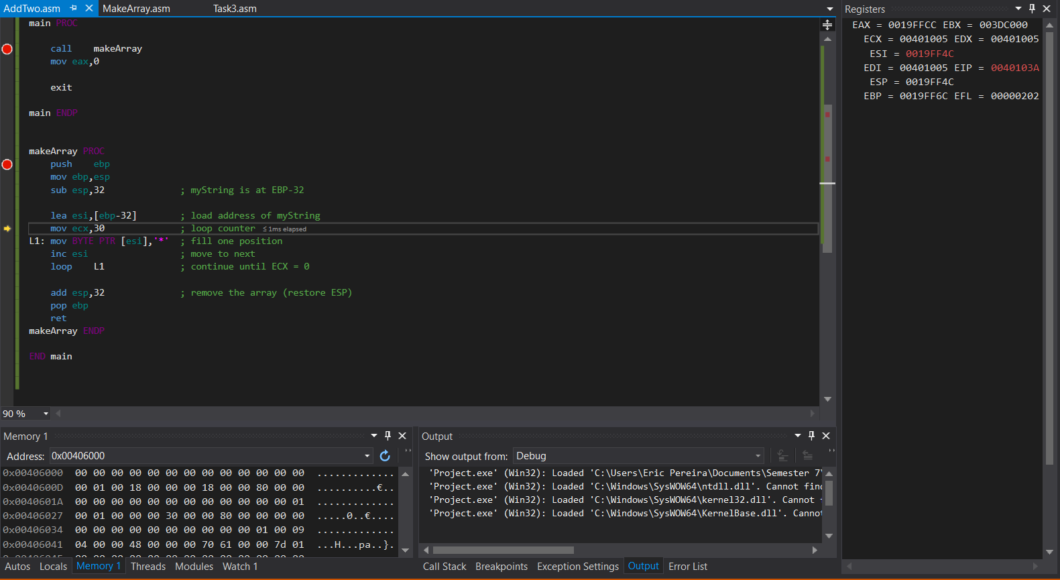

Task 1

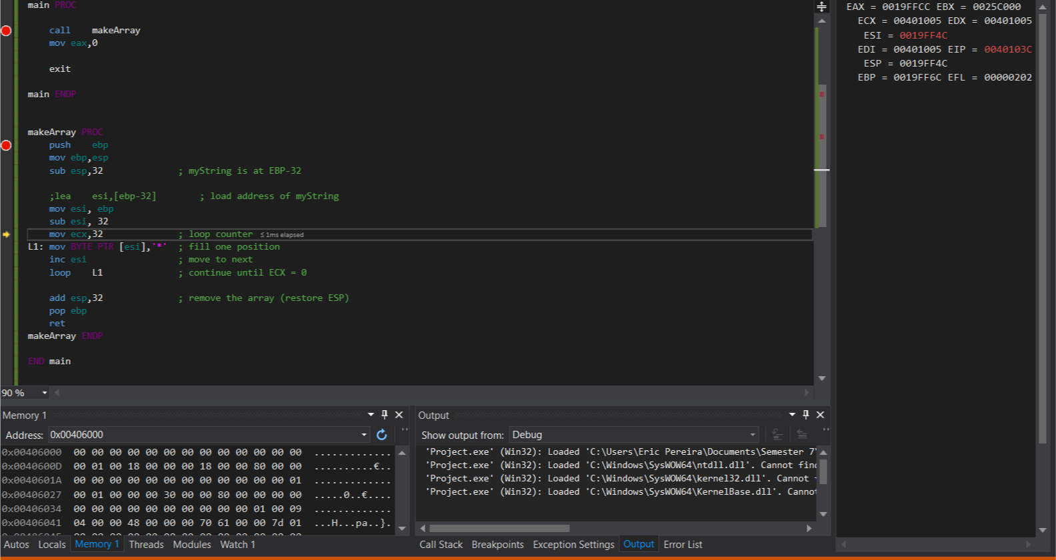

Task 2

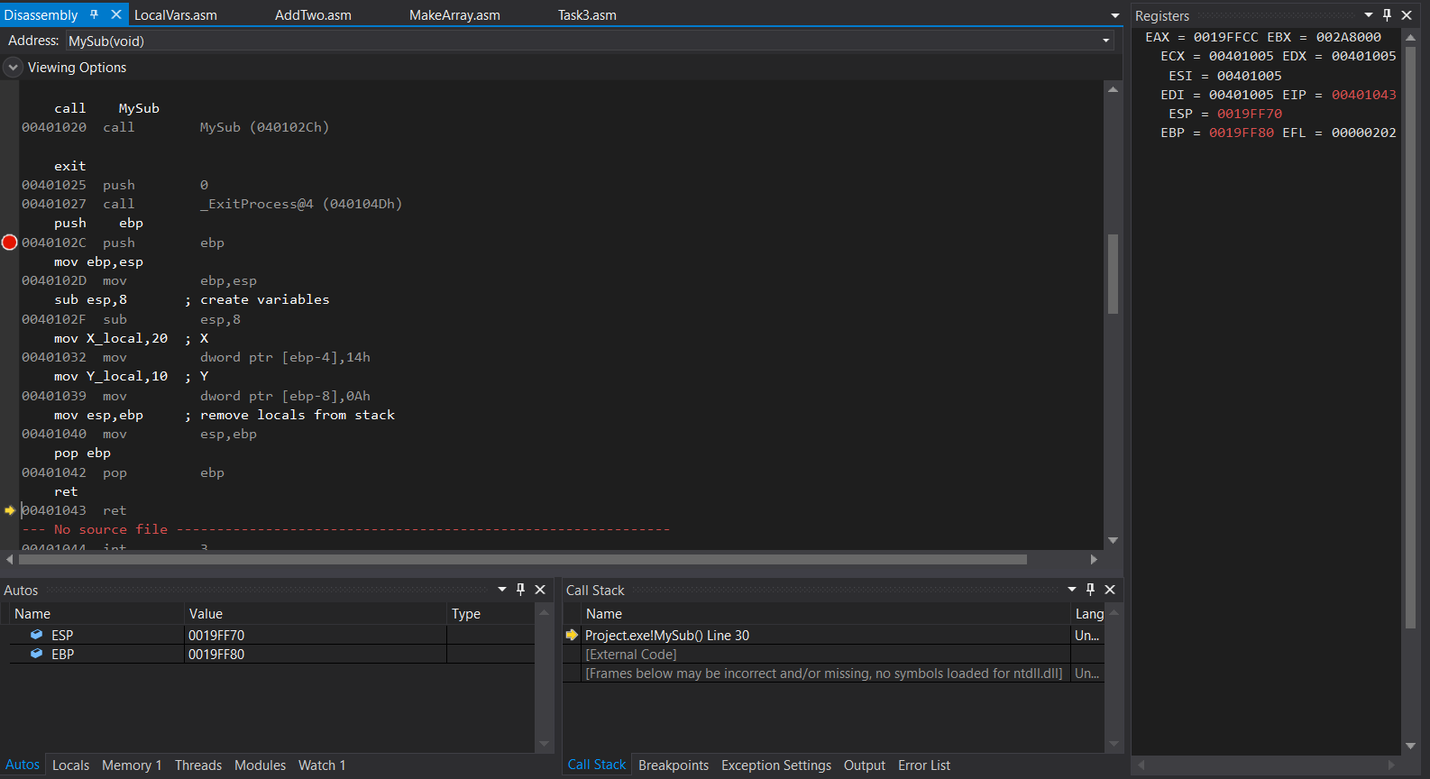

Task 3 Disassembly without implementing local variables

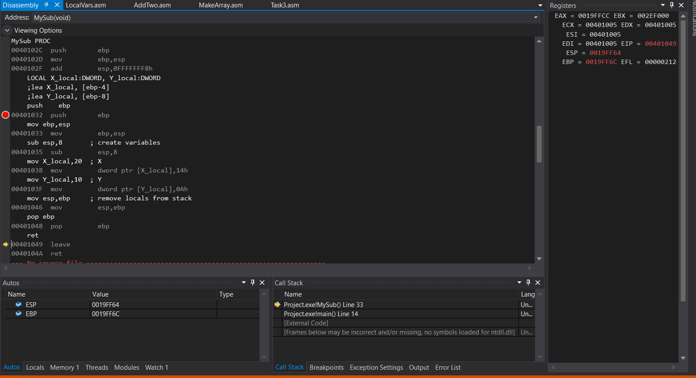

Task 3 Disassembly after implementing local variables

The difference is essentially nothing, I placed comments to help me understand that they store the DWORD in memory based on its size, so it may look different, but other than that and including the use of LOCAL the things lookc completely the same.

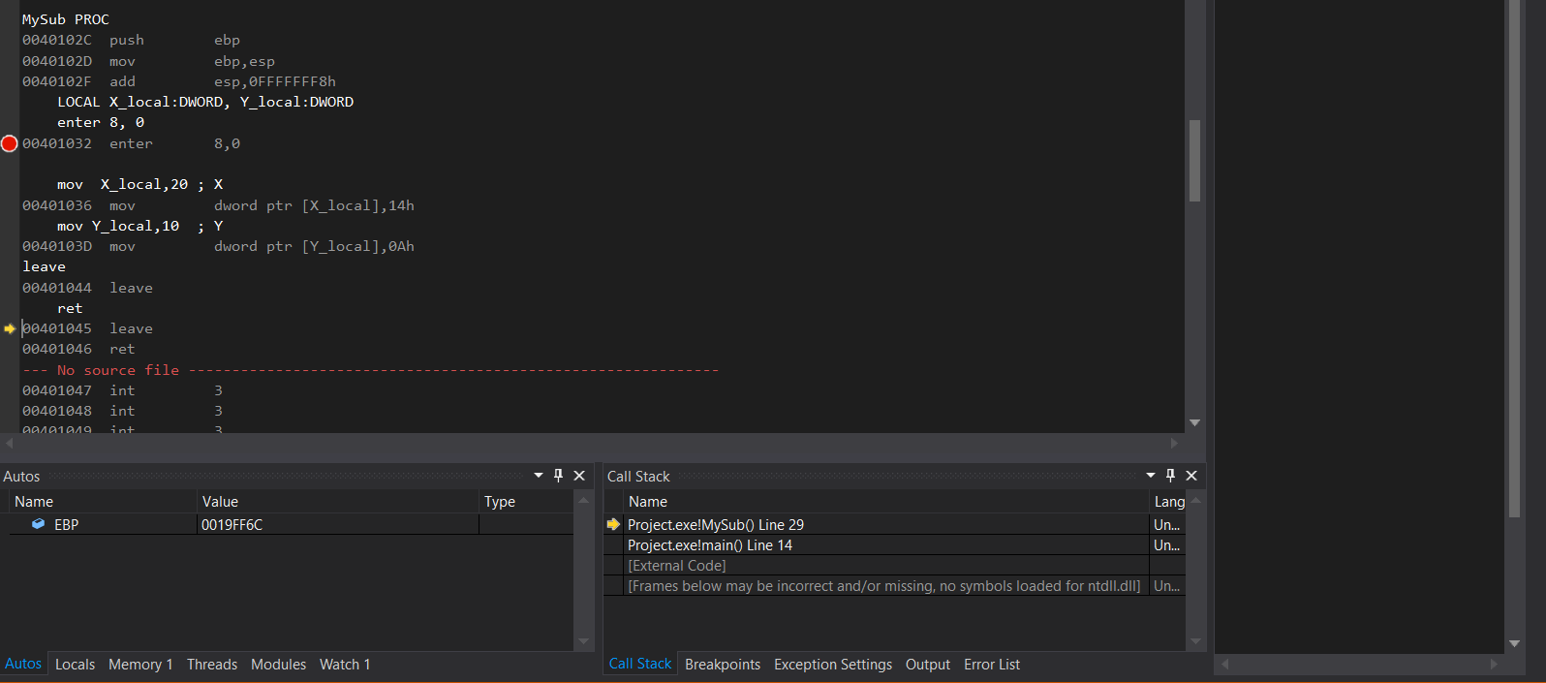

Task 4, using enter and leave